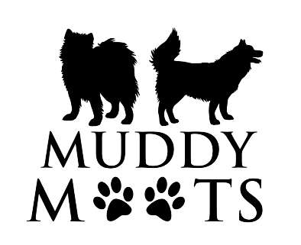
Privacy Policy

When making a booking with Muddy Moots you will be asked to provide details of your:

- pets name, age, breed, sex, and temperament so that we can identify your pet and provide care and grooming that is appropriate for their age, breed, and personality.

- contact details for any queries regarding your pet’s behaviour and care as well as to advise of collection times or cancellations.

- address if Muddy Moots are required to collect or drop off your dog as part of the agreed service you require.

- veterinary details for the unlikely occurrence that your pet may require emergency medical attention.

Muddy Moots will also record details of each appointment and any details pertaining to care of your pet in subsequent appointments – such as “Archie was not keen on the clippers being used on his face -next time use only scissors”
Muddy Moots records are stored securely, and you may request to see them, amend them or have them returned to you at any time. Requests can be made verbally or in writing via email, phone call or text message.
Should you cease to stop using Muddy Moots services payment data and contact information will be kept for no longer than is lawfully necessary and any other information will be retuned or destroyed.
Muddy Moots will only ever use details you have provided to provide efficient care and service to you and your pets, they will not be accessed, sold, or viewed by third parties at any time unless with your express permission.
Where any keys are held for access to your property these will be kept securely and separately from any identifying data.

